Example for Priority 1D (PAB Program Year 2023):

Priority 1D projects are described as projects in which (TGC 1372.0321(a)(4)):

(4)  on or after June 1, projects that are located in **counties, metropolitan statistical areas, or primary metropolitan statistical areas with area median family incomes at or below the statewide median family income** established by the United States Department of Housing and Urban Development.

In this example, we will be considering a project at our agency’s address (300 W 15th Street, Austin, TX 78701).

**HUD 2022 MFI Data (published by HUD):**

<https://www.huduser.gov/portal/datasets/il.html#2022_query>

Click on the “Click Here for FY 2022 MFI Documentation” button at the HUD link above. Then select “Texas – TX” for the state and the corresponding County or MSA/PMSA that the project is located in. In our example using the agency’s address, the project would be located in “Travis County” and then I would select “View County Calculations”. Scrolling to Step 5 of the County’s MFI Calculation, I would see that Travis County’s MFI is $110,300 since Travis County falls within the Austin-Round Rock, TX MSA (see the picture below).

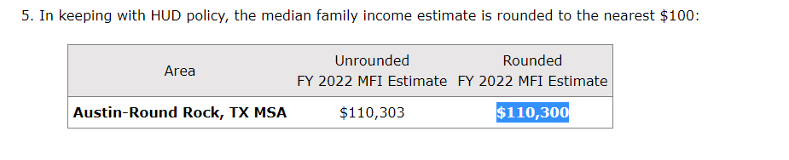

In order to determine Texas’ statewide MFI, we would use the following link:

**HUD 2022 Statewide Data (published by HUD):**

[https://www.huduser.gov/portal/datasets/il/il2022/2022summary.odn?inputname=STTLT*4899999999%2BTexas&selection_type=county&stname=Texas&statefp=48.0&year=2022](https://www.huduser.gov/portal/datasets/il/il2022/2022summary.odn?inputname=STTLT*4899999999%2BTexas&selection_type=county&stname=Texas&statefp=48.0&year=2022)

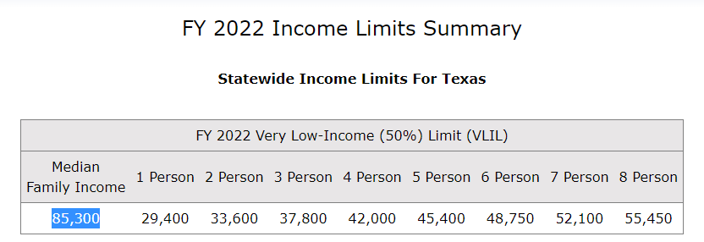

As indicated above, the statewide MFI for Texas is $85,300.

So since the project is located in a County/MSA/PMSA in which the AMFI (**$110,300**), as published by HUD, **IS NOT at or below** the statewide MFI (**$85,300**), as published by HUD, this project *would not* qualify as a Priority 1D residential rental project.